FAKE NEWS DETECTION SYSTEM USING FEATURE BASED OPTIMISED MSVM CLASSIFICATION
Block Diagrams (all)
Department of Computer Science and Engineering, [COLLEGE NAME]
Batch C6 (CSE-C) · Academic year [ACADEMIC YEAR]
Table 1: Project team
S.No. | Student name | Roll number
1 | Neela Mojes | 23K91A05H1
2 | Noor Saniya | 23K91A05H4
3 | Malkajgiri Akshitha | 23K91A05E2
4 | Maravajhala Radha Sri Aashritha | 23K91A05E7

Project guide: K Rajasekhar Rao
Chapter and section numbers quoted in the text (for example Chapter 8 or Section 6.2) refer to the full project report, 17.Final Document. Figures and tables in this document are numbered from 1.

1. INDEX OF DIAGRAMS
Every diagram was generated from the real design by scripts/docs_build/make_diagrams.py (matplotlib, 150 dpi) and mirrors the code in backend/main.py and src/. The application has no SQL database, so the entity-relationship diagram shows its file-based data model.
Table 2: Diagrams in this document
No. | Diagram | Image file
1 | System architecture | docs/diagrams/01_system_architecture.png
2 | High-level workflow | docs/diagrams/02_high_level_workflow.png
3 | Data flow diagram, level 0 (context) | docs/diagrams/03_dfd_level0.png
4 | Data flow diagram, level 1 | docs/diagrams/04_dfd_level1.png
5 | Data flow diagram, level 2 (process 3.0) | docs/diagrams/05_dfd_level2.png
6 | UML class diagram | docs/diagrams/06_uml_class_diagram.png
7 | Sequence diagram: detecting one article | docs/diagrams/07_sequence_diagram.png
8 | Use case diagram | docs/diagrams/08_use_case_diagram.png
9 | Entity-relationship diagram (file store) | docs/diagrams/09_er_diagram.png
10 | Flowchart of the core algorithm | docs/diagrams/10_core_algorithm_flowchart.png
11 | Feature pipeline | docs/diagrams/11_feature_pipeline.png
12 | Sequence diagram: retraining | docs/diagrams/12_retrain_sequence.png

2. DIAGRAMS

System architecture
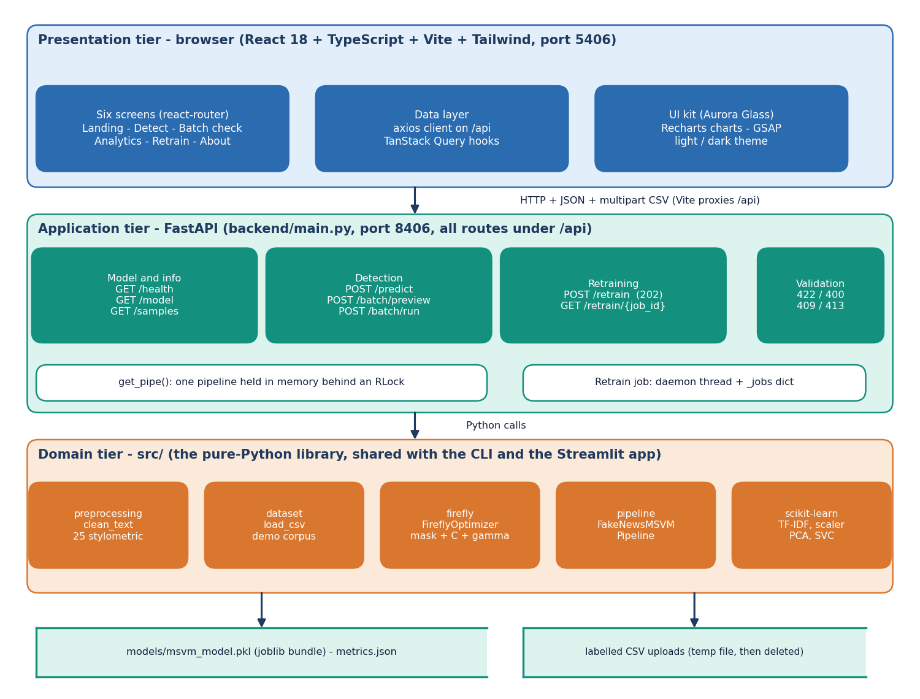
Figure 1: System architecture of TruthGlow: presentation, application and domain tiers over two file stores.
The system has three tiers over two stores. The presentation tier is a React 18 + TypeScript single-page application built with Vite and Tailwind CSS and served on port 5406; it has six screens (the landing page and the Detect, Batch check, Model analytics, Retrain and About screens), an axios client that sends every call to /api, and TanStack Query hooks. The application tier is a thin FastAPI service (backend/main.py, port 8406) with eight endpoints under /api, one pipeline object held in memory behind a re-entrant lock, and a background thread for retraining whose state lives in a dictionary. The domain tier is the library src/ (preprocessing, dataset, firefly, pipeline) built on scikit-learn; the same library is used by the command-line scripts and by the original Streamlit application, so the three front ends cannot drift apart. The first store is the joblib bundle models/msvm_model.pkl (with metrics.json written by train.py); the second is the temporary file that holds an uploaded labelled CSV while it is parsed and is deleted afterwards. There is no SQL database and no user account.

High-level workflow
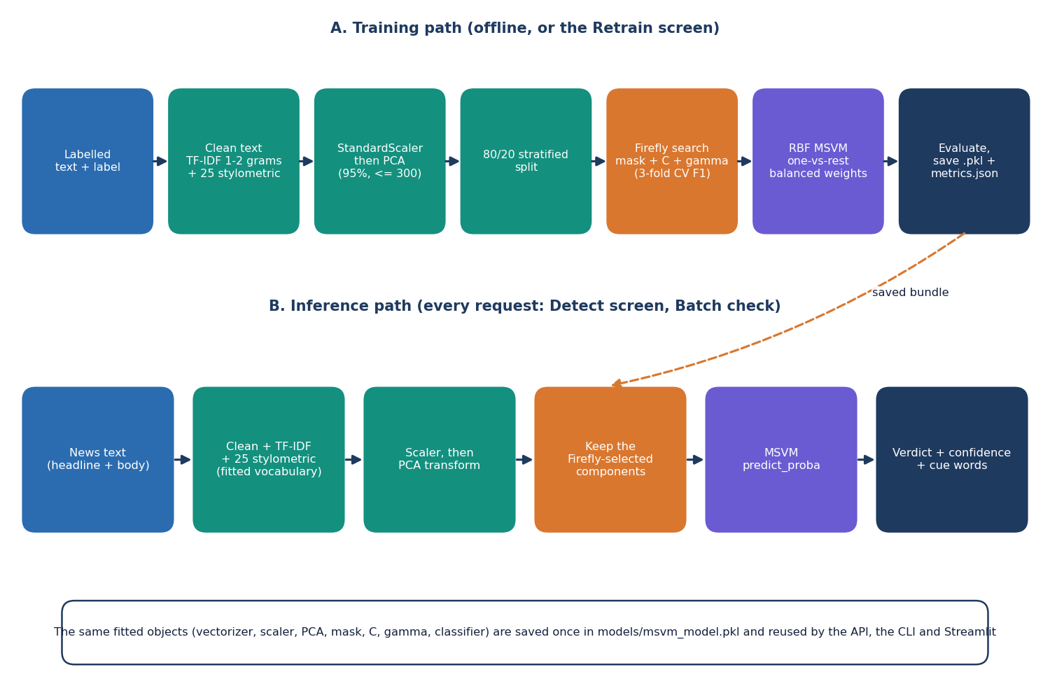
Figure 2: High-level workflow: the training path (offline or from the Retrain screen) and the inference path.
The workflow has two paths that share the same fitted objects. The training path takes labelled text, cleans it, builds TF-IDF (one- and two-word groups) and 25 stylometric features, standardises and reduces them with PCA, splits the result 80/20 with stratification, lets the Firefly algorithm choose a subset of the PCA components together with C and gamma, fits the final RBF multi-class SVM with balanced class weights, evaluates it and saves the whole bundle. The inference path takes a headline and body text, applies the same fitted vectoriser, scaler and PCA, keeps only the components the Firefly search selected, and asks the SVM for a class and for class probabilities. Because the fitted vectoriser, scaler, PCA and mask are stored together in one file, training and prediction cannot use different preprocessing.

Data flow diagram, level 0 (context)
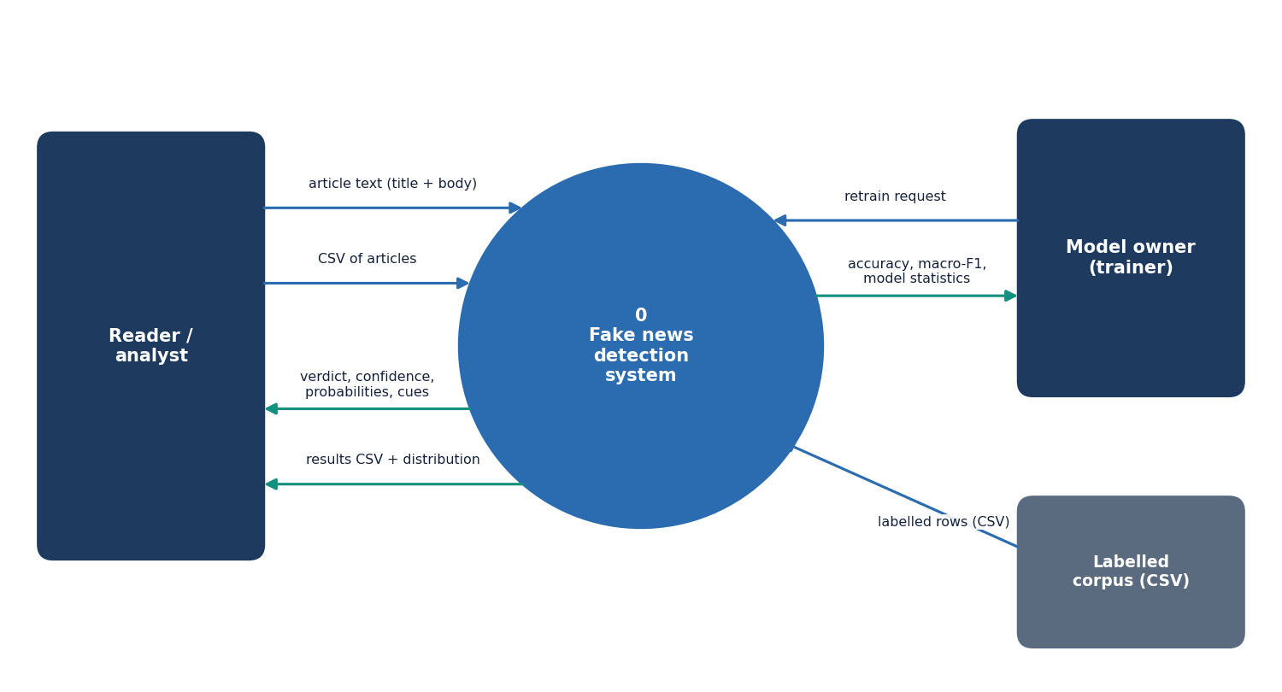
Figure 3: Level 0 data flow diagram: the system as one process with three external entities.
At the context level the system is one process. The reader or analyst sends article text (a headline and body) or a CSV of articles and receives a verdict, a confidence, class probabilities and cue words, or a results CSV with the distribution of verdicts. The model owner sends a retrain request with the Firefly budget and receives the accuracy, the macro-F1 and the model statistics. The labelled corpus, a CSV file with a text column and a label column, supplies the training rows. The two human entities use the same screens; they are separated only to show who typically starts each flow.

Data flow diagram, level 1
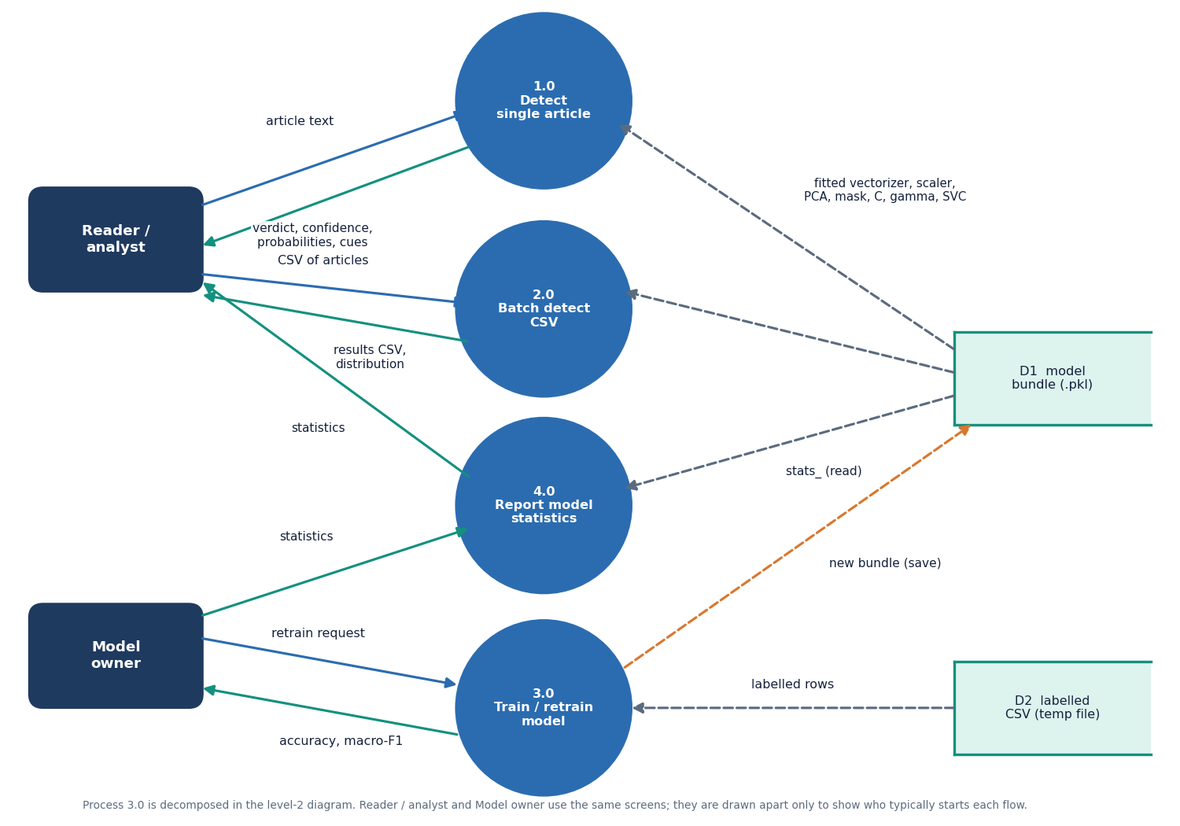
Figure 4: Level 1 data flow diagram: four processes and two data stores.
Level 1 has four processes. 1.0 Detect single article takes article text from the reader and returns the verdict, confidence, probabilities and cues, reading the fitted vectoriser, scaler, PCA, mask, C, gamma and classifier from D1, the model bundle. 2.0 Batch detect CSV takes a CSV of articles, reads D1 in the same way and returns the results CSV and the distribution of verdicts. 3.0 Train / retrain model takes the retrain request from the model owner and the labelled rows held temporarily in D2, writes a new bundle to D1 and returns the accuracy and macro-F1. 4.0 Report model statistics reads the statistics stored inside D1 and returns them (accuracy, macro-F1, confusion matrix, Firefly curve, classification report, baseline) to the screens. Process 3.0 is expanded in the level 2 diagram.

Data flow diagram, level 2 (process 3.0)
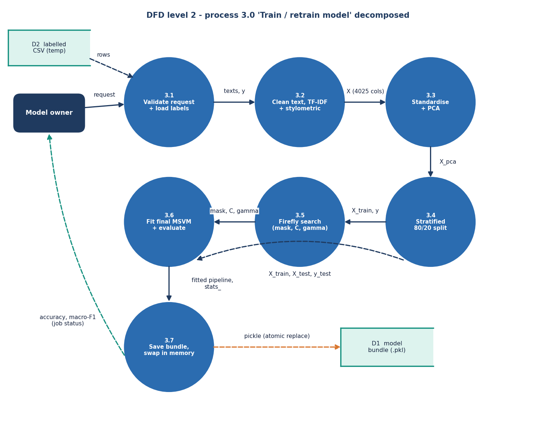
Figure 5: Level 2 data flow diagram: the seven steps inside process 3.0, Train / retrain model.
Process 3.0 expands into seven steps that follow FakeNewsMSVMPipeline.fit and the retraining endpoint. 3.1 validates the request (Firefly budget within range, at least 30 rows, a label column) and loads the labelled rows from the temporary CSV (D2) or builds the demo corpus. 3.2 cleans the text and builds the 4,025-column matrix of TF-IDF and stylometric features. 3.3 standardises it and applies PCA. 3.4 performs the stratified 80/20 split. 3.5 runs the Firefly search on the training part and returns the mask, C and gamma. 3.6 fits the final SVM on the masked training part and evaluates it on the test part, producing the statistics. 3.7 saves the bundle to a temporary file, replaces the model file atomically, swaps the in-memory pipeline under the lock and reports the accuracy and macro-F1 as the job status.

UML class diagram
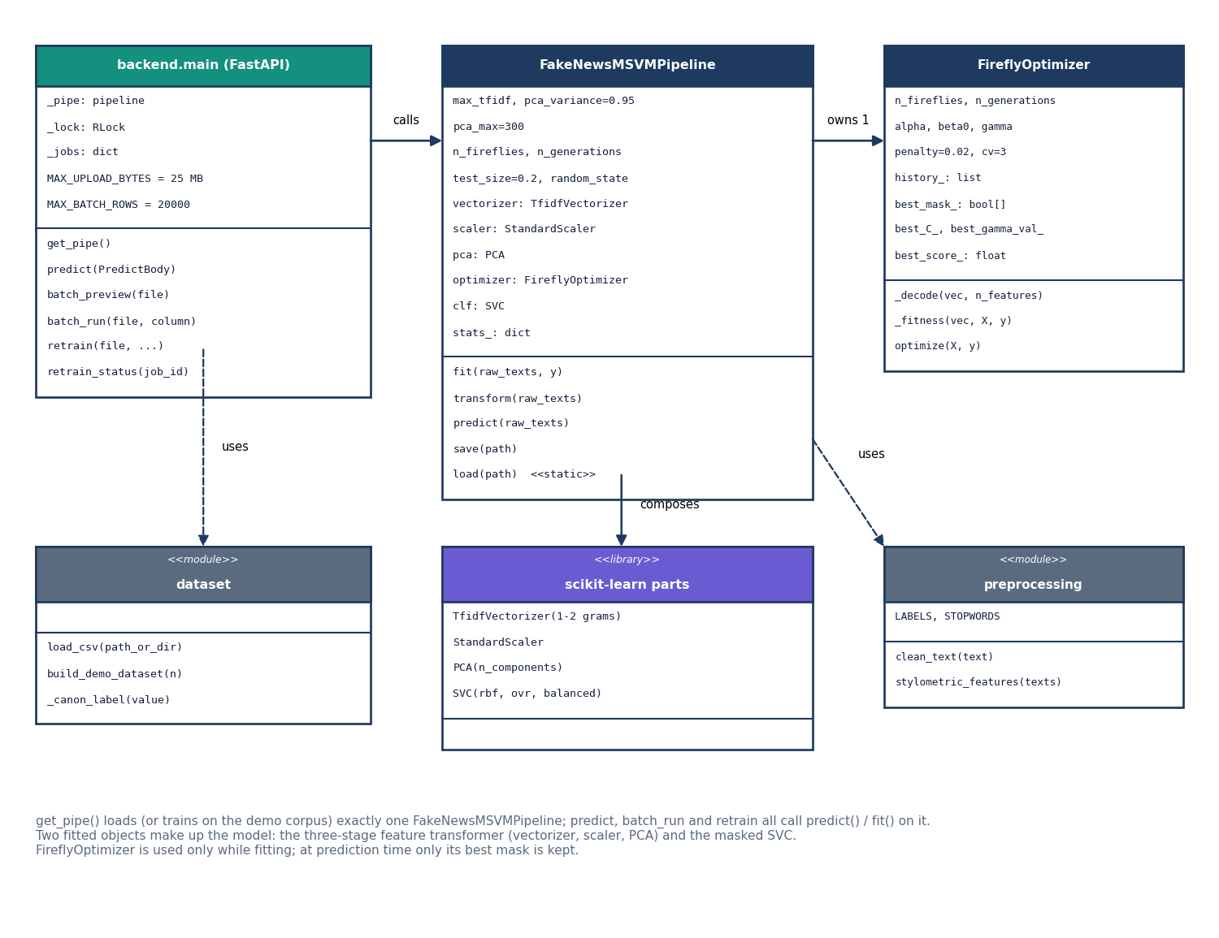
Figure 6: UML class diagram of the main classes and modules.
The library is small, so the diagram shows the real classes and the modules around them. backend.main holds the module-level state (_pipe, _lock, _jobs) and the upload limits, and its endpoint functions call get_pipe(), which returns the one FakeNewsMSVMPipeline. The pipeline owns exactly one FireflyOptimizer and composes the scikit-learn parts: TfidfVectorizer, StandardScaler, PCA and SVC; it uses the preprocessing module (clean_text, stylometric_features, the label constants). The dataset module (load_csv, build_demo_dataset) is used by the backend when it builds or retrains a model. The optimiser is needed only while fitting; at prediction time only its best mask is kept, so a loaded pipeline carries a minimal optimiser object holding the mask, C and gamma.

Sequence diagram: detecting one article
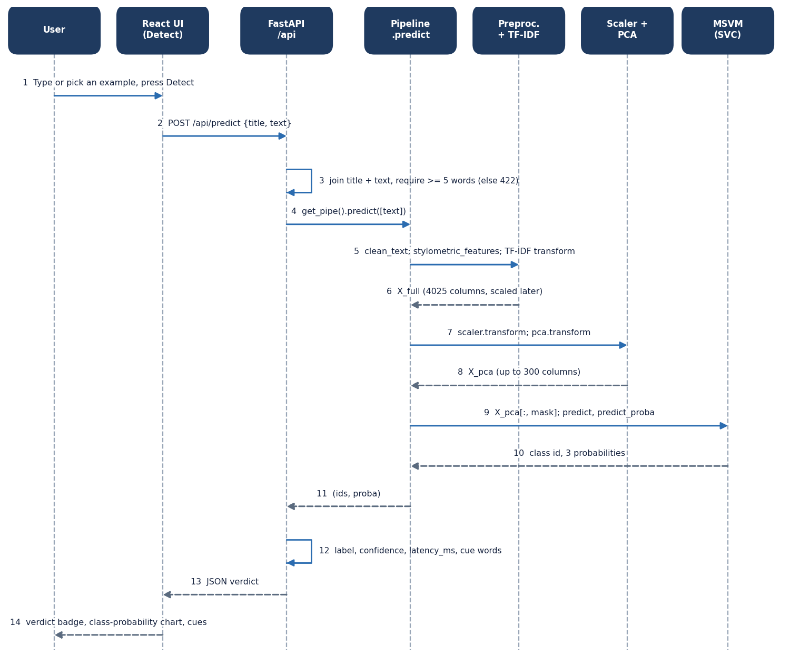
Figure 7: Sequence diagram of one detection request, from the Detect screen to the SVM and back.
The user types or loads an article and presses Detect (step 1); the page posts {title, text} to /api/predict (2). The backend joins the title and text and rejects fewer than five words with status 422 (3), then asks the pipeline to predict (4). The pipeline cleans the text, computes the stylometric features and the TF-IDF transform (5-6), scales and projects with PCA (7-8), keeps the selected components and asks the SVM for the class and the probabilities (9-10). The pipeline returns the class ids and probabilities (11); the backend builds the label, the confidence (the largest probability), the latency in milliseconds and the cue words (12) and returns the JSON verdict (13), which the page shows as a verdict badge, a class-probability chart and two cue lists (14).

Use case diagram
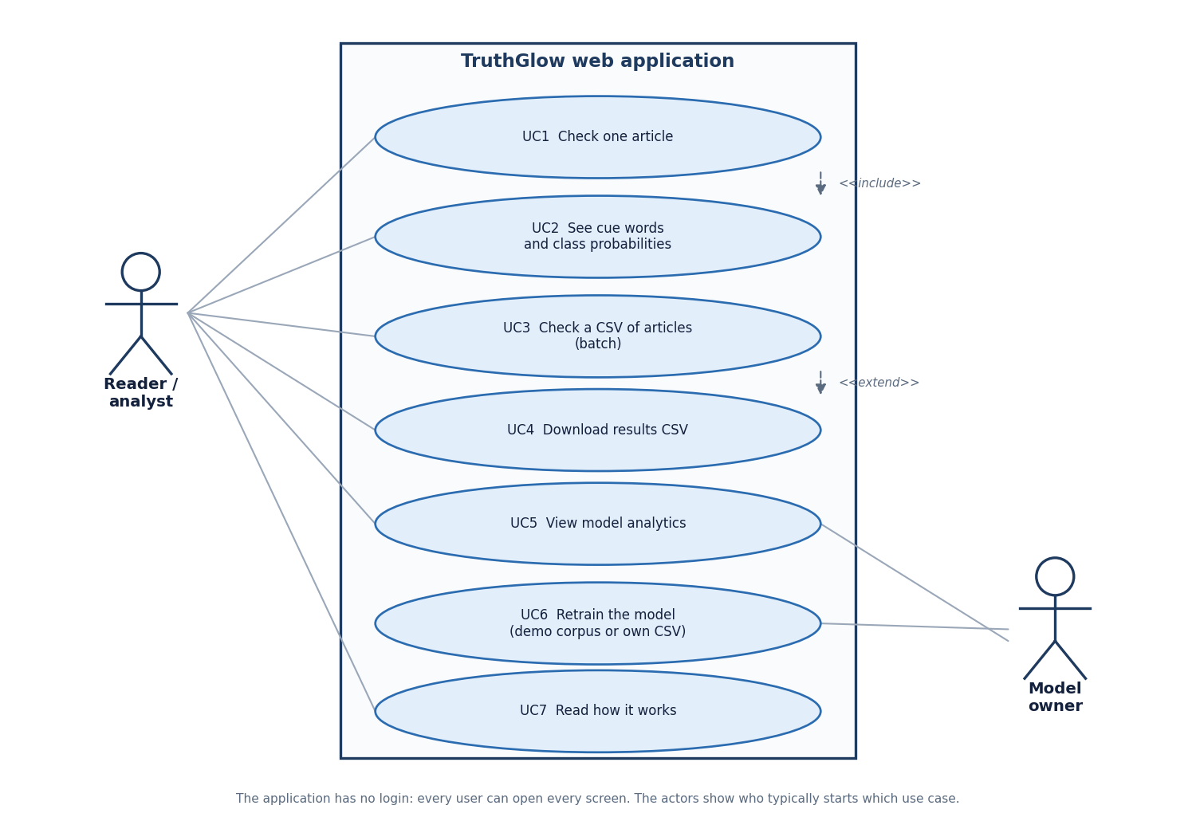
Figure 8: Use case diagram: seven use cases and two actors.
The reader or analyst can check one article (UC1), which includes seeing the cue words and class probabilities (UC2); check a CSV of articles (UC3), with the option to download the results CSV (UC4); view the model analytics (UC5); and read how the system works (UC7). The model owner retrains the model with the demo corpus or an own CSV (UC6) and also views the analytics. The application has no login, so every user can open every screen; the two actors only show who typically starts which use case.

Entity-relationship diagram (file store)
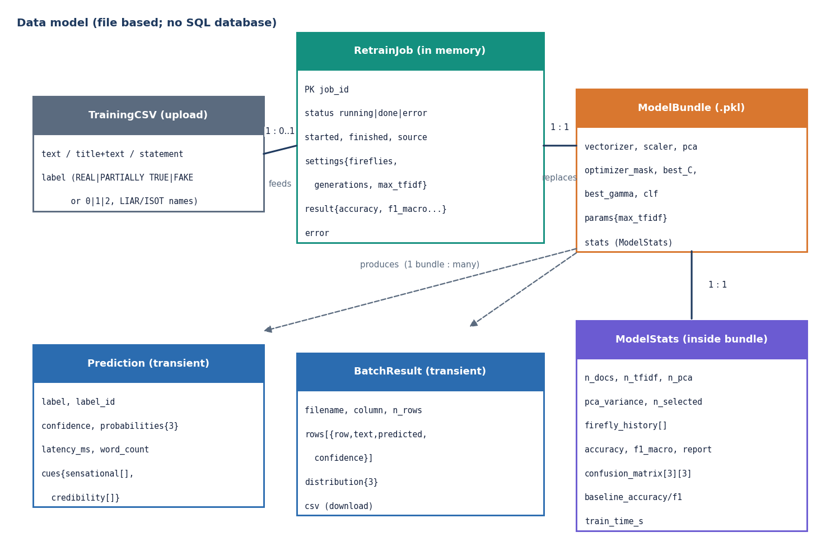
Figure 9: Entity-relationship diagram of the data model; the product has no SQL database.
TruthGlow stores no records in a database. A TrainingCSV, an upload with a text column and a label column, feeds at most one RetrainJob; the job lives only in the memory of the API process (identified by a 12-character job id, with its status, source, settings and result). A finished job replaces the single ModelBundle file, which holds the fitted vectoriser, scaler, PCA, mask, C, gamma, classifier and parameters together with its ModelStats (document count, feature counts, Firefly history, accuracy, macro-F1, classification report, confusion matrix, baseline scores and training time). One bundle produces many Predictions and BatchResults, but these are transient responses and are never stored.

Flowchart of the core algorithm
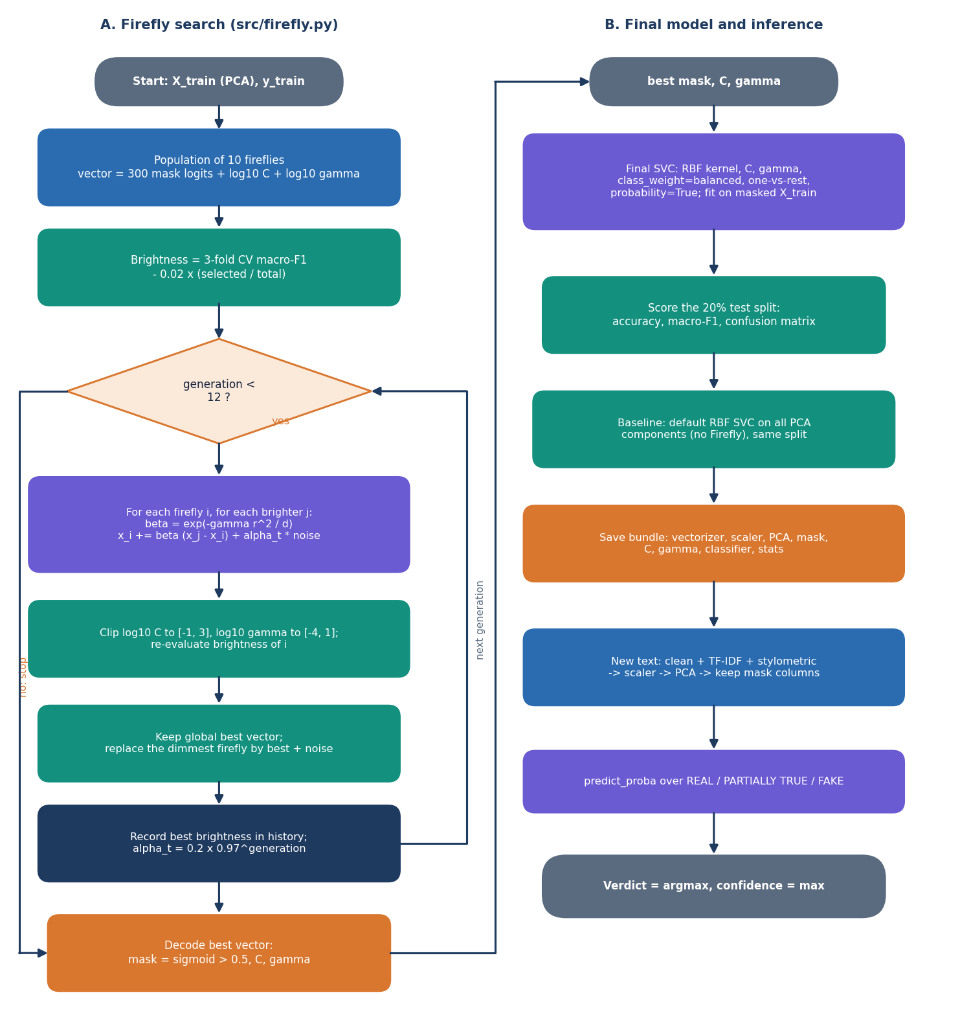
Figure 10: Flowchart of the core algorithm: (A) the Firefly search and (B) the final model and inference.
Part A is FireflyOptimizer.optimize. A population of ten fireflies is created; each is a vector of one mask logit per PCA component plus log10 C and log10 gamma. The brightness of a firefly is the three-fold cross-validated macro-F1 of an RBF SVM trained on the masked training data, minus 0.02 times the share of components kept. For each of twelve generations every firefly moves towards every brighter one by a step that shrinks with distance, plus a random term whose size decays by 0.97 per generation; C and gamma are clipped to their ranges and the brightness is re-evaluated. The best vector is kept, the dimmest firefly is replaced by the best plus noise, the best brightness is recorded in the history and the loop repeats. The best vector is then decoded: a component is kept when its sigmoid exceeds 0.5. Part B fits the final SVM on the masked training data, scores the held-out 20 %, fits a default SVM on all components as the baseline, saves the bundle and then serves predictions as arg-max of the decision function with probabilities from Platt scaling.

Feature pipeline
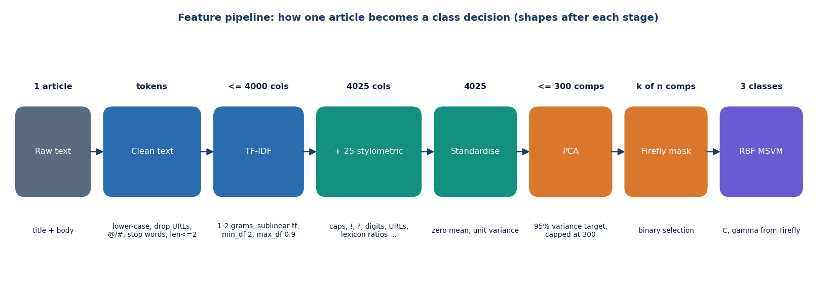
Figure 11: Feature pipeline: the shape of one article's representation after each stage.
One article becomes a vector of up to 4,000 TF-IDF values (unigrams and bigrams, sublinear term frequency, minimum document frequency 2, maximum 0.9) joined to 25 stylometric values, 4,025 numbers in all. Standardisation gives each column zero mean and unit variance. PCA then keeps as many components as are needed for 95 % of the variance, but never more than 300; the Firefly mask keeps a subset of those; and the RBF multi-class SVM decides between the three classes. On the real LIAR2 training data the 300-component cap is reached every time and keeps only 29.3% of the variance; on the synthetic demo corpus 95 % is reached with 136 components.

Sequence diagram: retraining
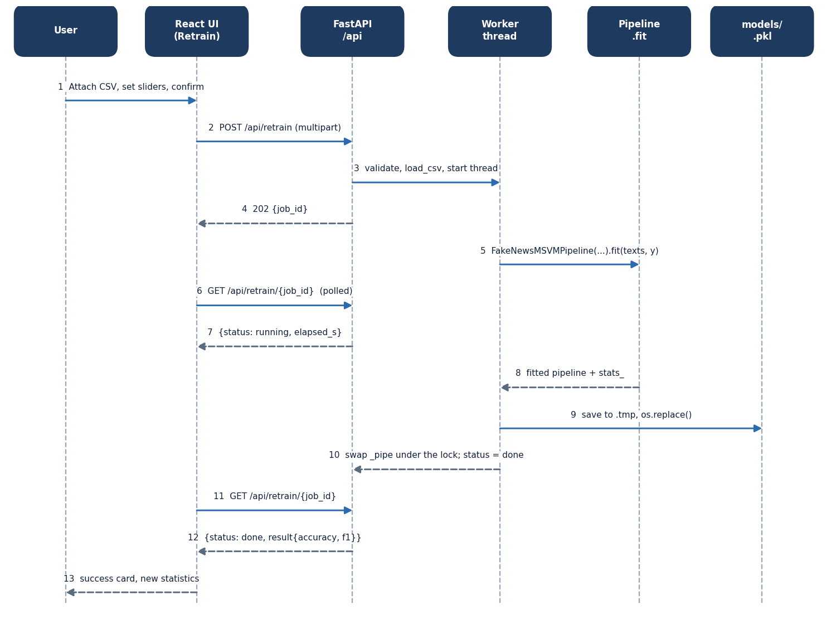
Figure 12: Sequence diagram of retraining: upload, background job, polling and hot swap.
The user attaches a CSV, sets the sliders and confirms (1). The page posts the multipart form to /api/retrain (2); the backend validates the ranges and the file, parses it, registers the job and starts a daemon thread (3) and answers at once with status 202 and the job id (4). The thread fits a new pipeline (5). Meanwhile the page polls /api/retrain/{job_id} every two seconds (6-7); the job id is also kept in the browser's local storage so that a page reload can resume the polling. When fitting ends (8) the thread saves the bundle to a .tmp file and renames it over the model file (9), swaps the in-memory pipeline under the lock and marks the job done (10); the next poll returns the accuracy and macro-F1 (11-12) and the page shows the success card and refreshes the analytics (13). If training fails the job is marked as an error and the previous model stays in use.

